**COMP 3540**

**Project Idea**

**Winter 2021**

**Yu leng**

**03/10/2021~**

**~03/26/2021**

**Project: Game concept idea crowdfunding and forum**

**Description**

My project will be a user communication type website. The theme is a concept game project of mine. There will be a simple concept image and text description on the website. The main purpose is to attract players and conduct crowdfunding or get new ideas, which also includes attracting partners to join. In addition to the description of the game project, the website will also include user registration, login and logout, and a simple user information form. Users can simply manage their personal information. Users can post various questions on the "Questions" page, search, or list all posted questions, or delete questions. On the partner page, there will be more specific information about the game, the main purpose of which is to discuss how to make the game and prepare for it. User now can upload their pictures to the webpage and release their user icon to their own image.

**Detail Function**

User Join in

Users can register as website members

User Sign in

Users can log in to the website after registering

User Log Out

Users can log out at any time

Change User’s profile

User can change their password or manage their personal information.

User Question post

Users can post various questions about the game project.

User Question delete

Users can delete posted various questions about the game project.

User list all posted question

Users can list all posted various questions about the game project.

User Question search

Users can search all posted various questions about the game project.

User image upload

User can upload their pictures to the webpage and release their user icon

Answer edit or delete

Users can post an answer by click the answer button. To see the answer, the user can search the questions to see the answer. If the question deleted, the answer will delete also.

Questionnaire part

For this part will have a modal window to let user answer some questions about the concept game include ideas and feeling.

Unsubscribe part

In this part user can unsubscribe or delete their personal information include user name, the password and email.

Additional new idea

This part could let user post their new ideas of the game or new idea of the game setting if they want, this part could help and complete the game project.

**Page layout diagrams, and user interface**

The current plan for user interface and layout diagrams is based on a simple style, aiming to allow users to focus on the game project rather than the website itself.

For the next pages are paper prototypes, and there’re include Description page, Survey page and About US page:

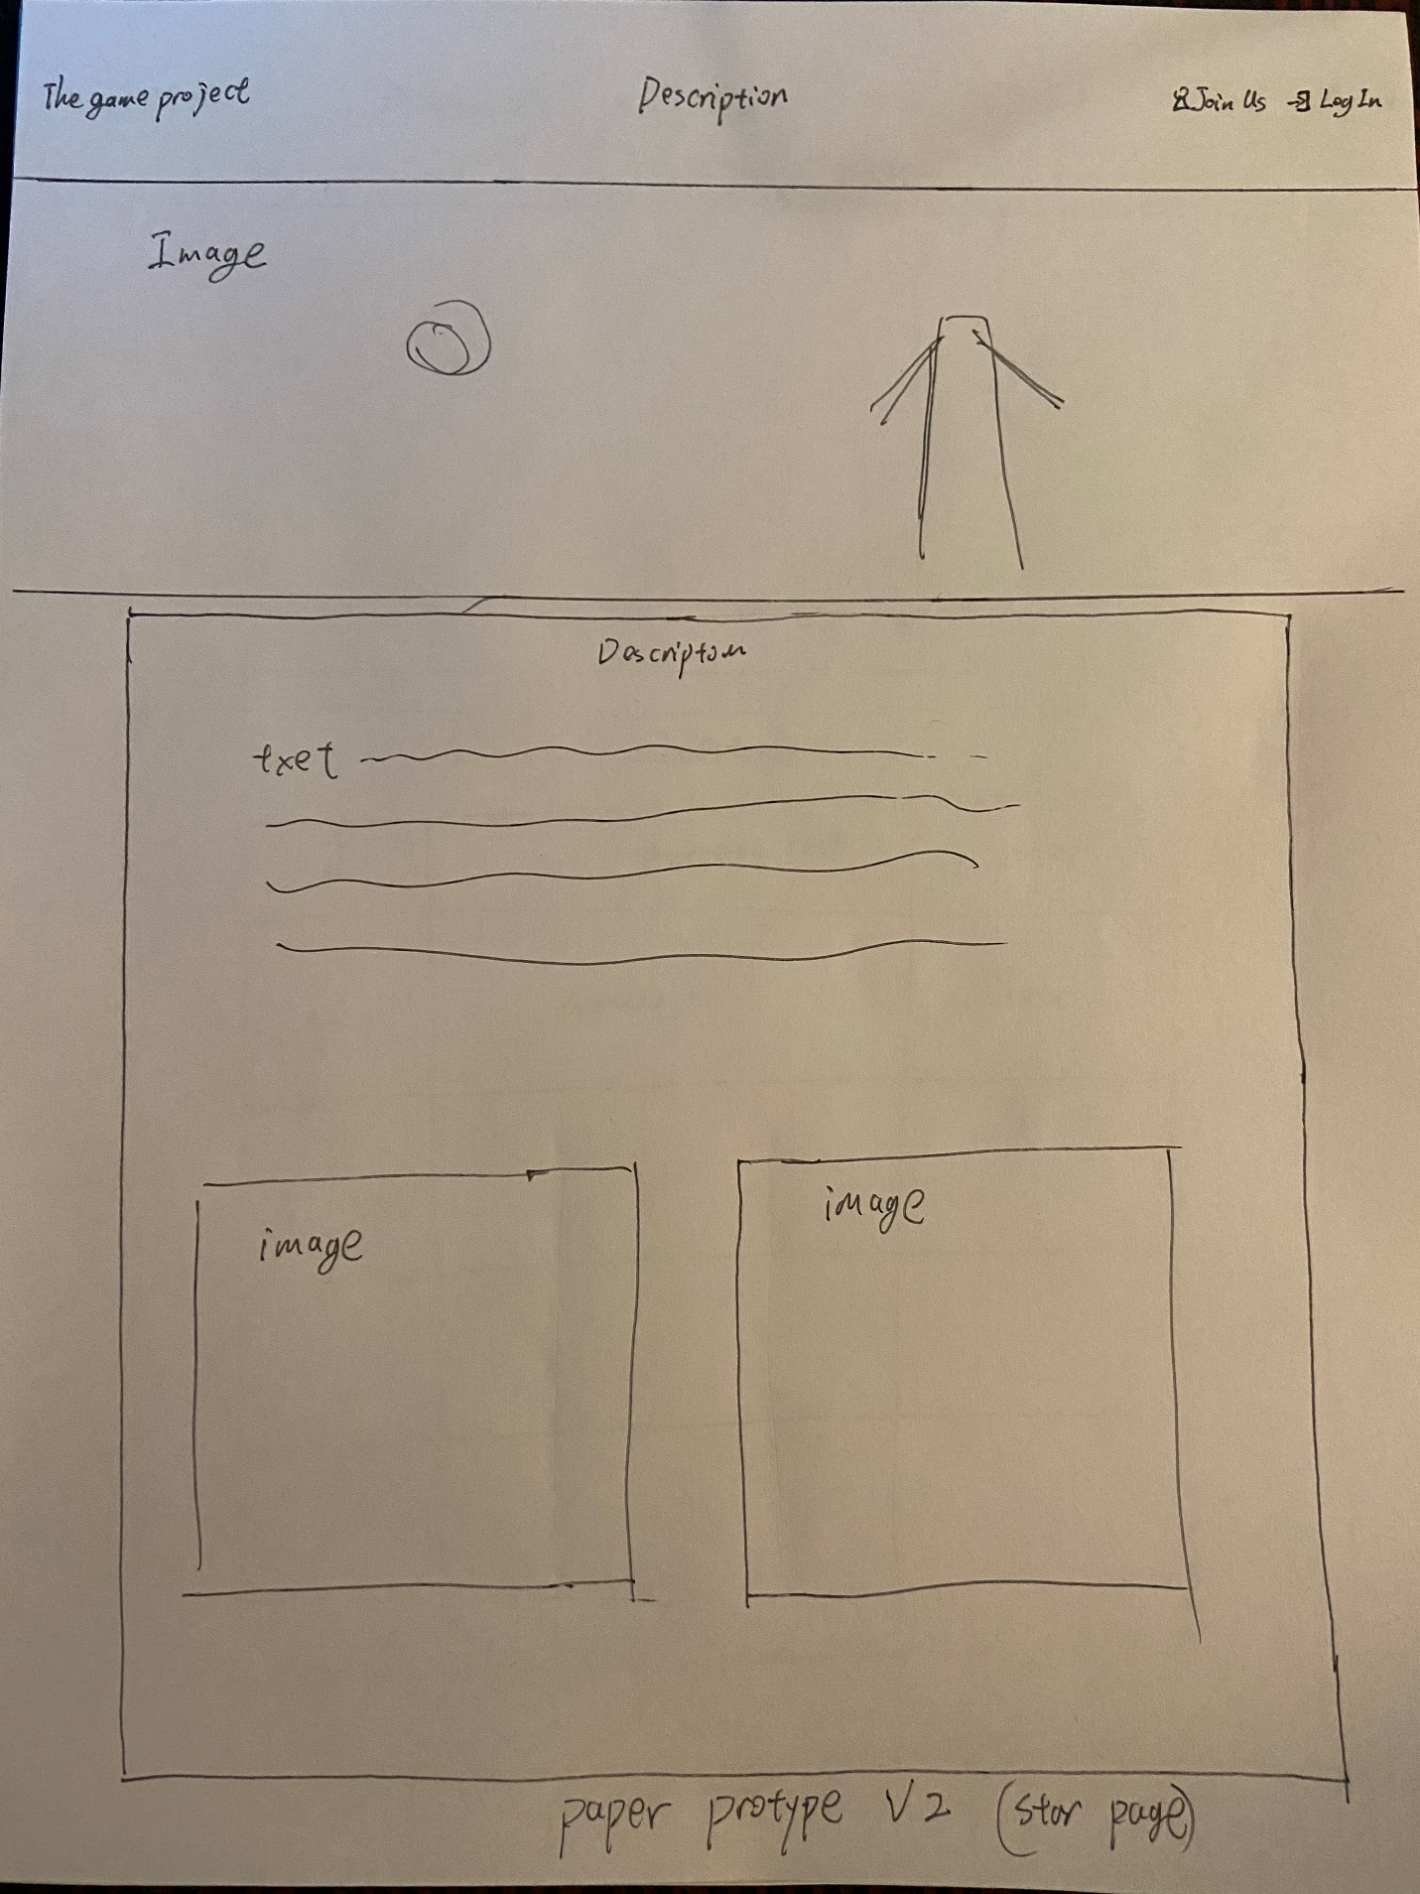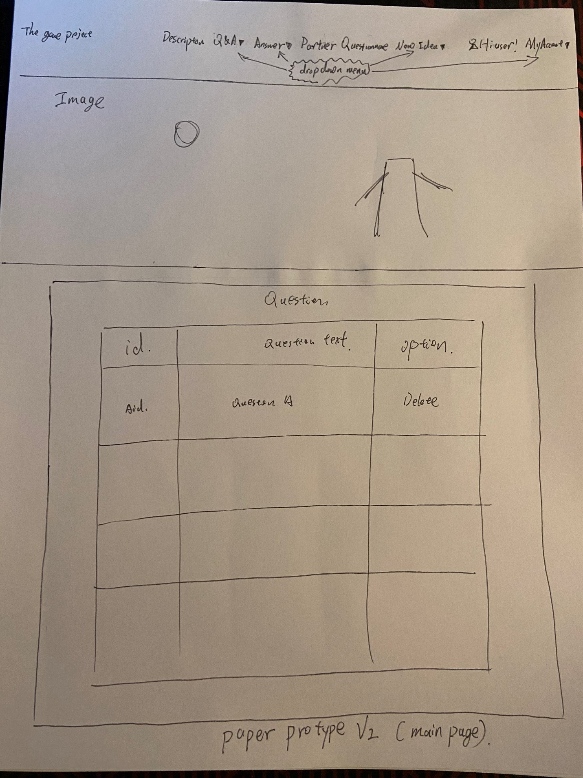

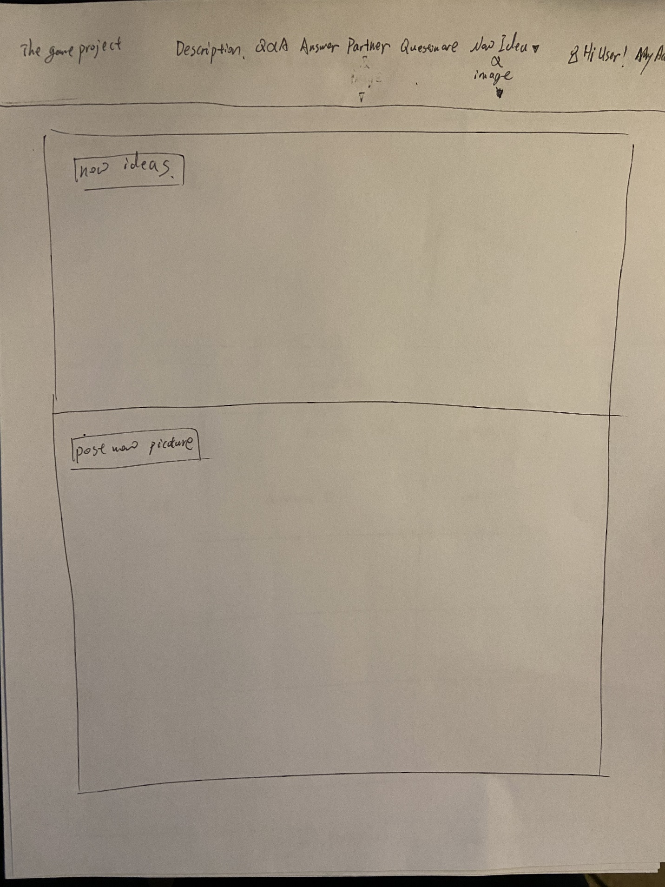

**Final Test**

This website project is used to collect ideas from all players, visitors, and those who are interested. The functions of this website are to help users get into the website and write any ideas, images, and questions they are interested in. Those functions are user login, sign in, sign out, change the user password, unsubscribe, post, list, delete, answer posted questions, upload image or user icon, Questionnaire, post new ideas.

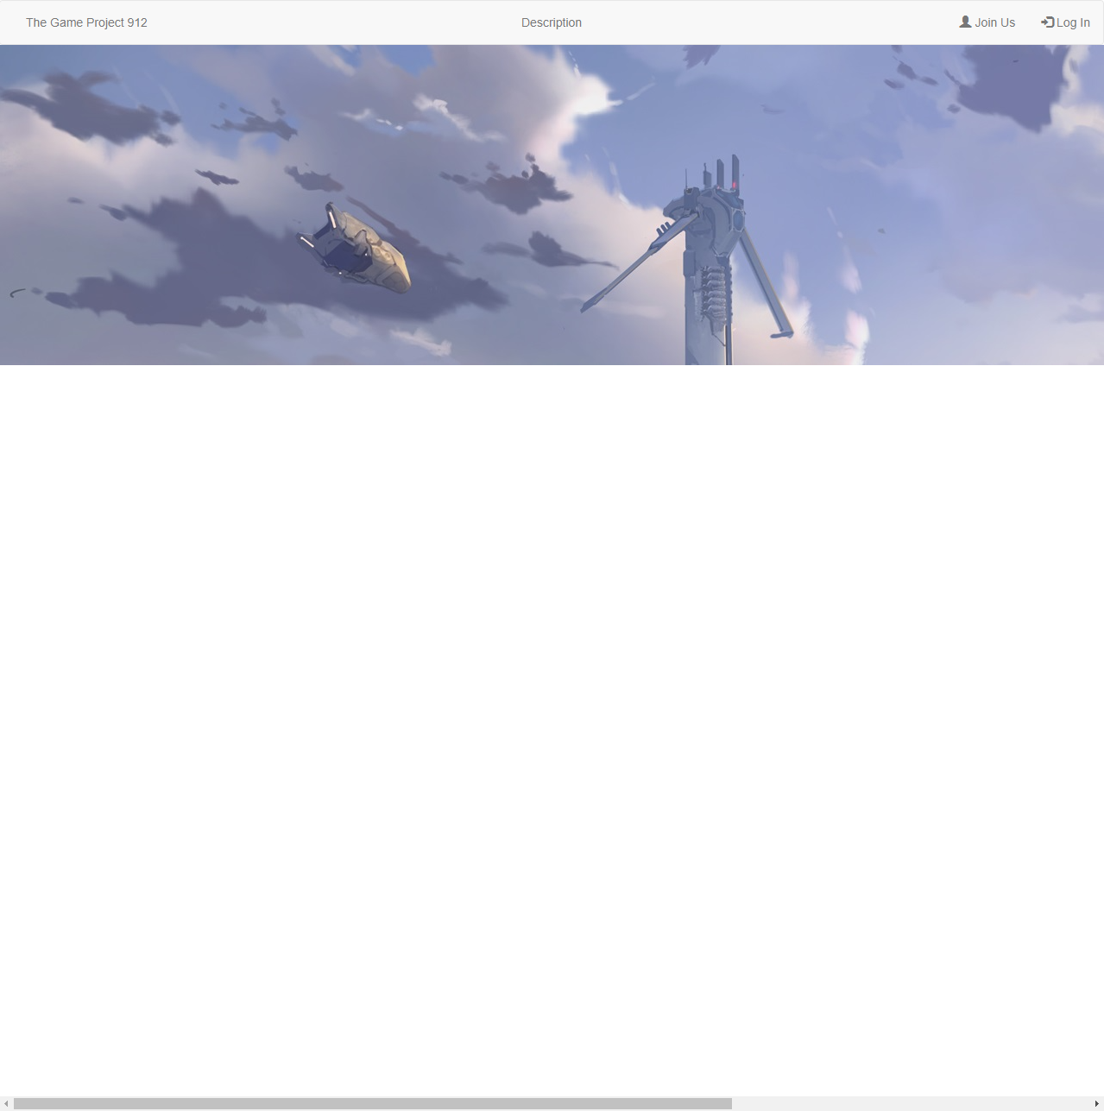

To test those functions, we choose “join in” and enter the information username “test”, password “test”, and email “test”, that information will store in the database “UserLeng”. If we successfully registered, the website will display the alert “success registered”. The username will be created and we can use it to log in to the main page.

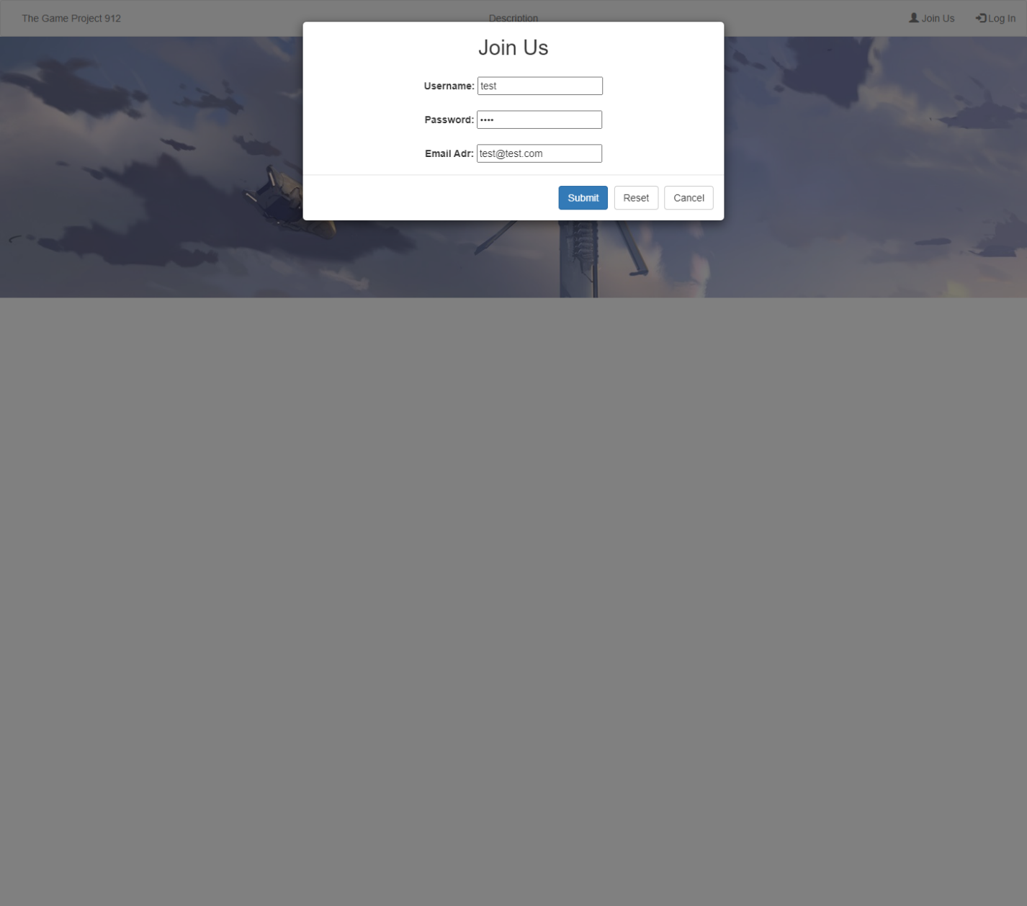

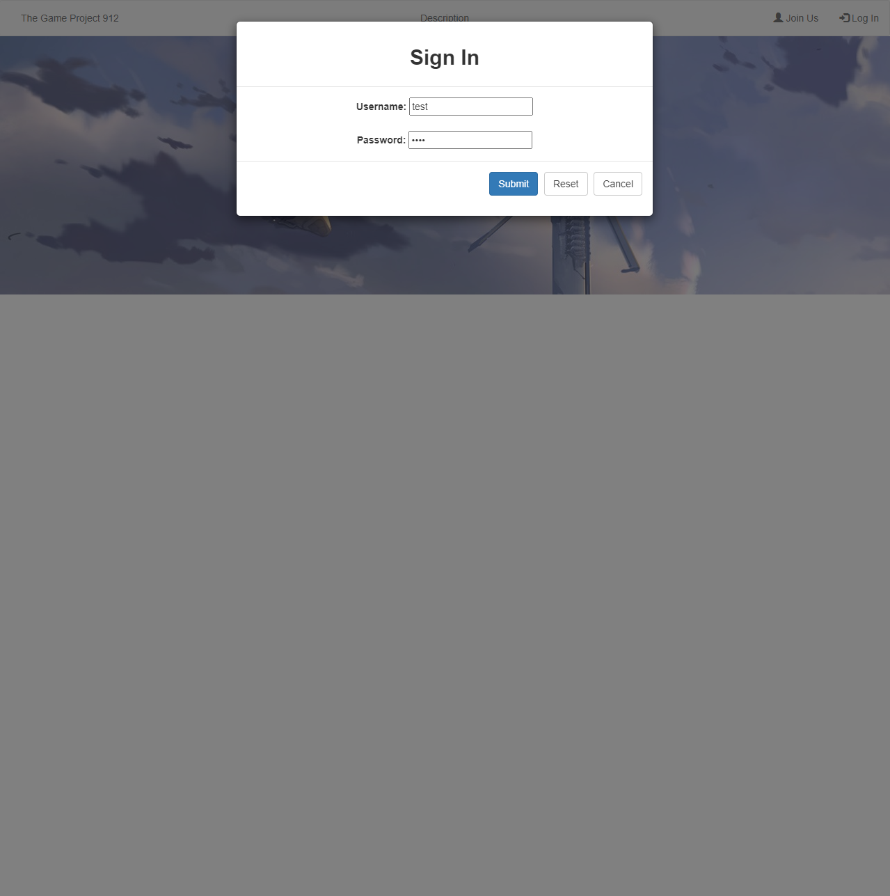

The main menu bar is at the top of the main page, menus in the menu bar are “Description”, “Q&A”, “Answer”, “Image”, “Questionnaire” and “New Idea”. The “Description” is used to describe the ideas and concepts with texts and images.

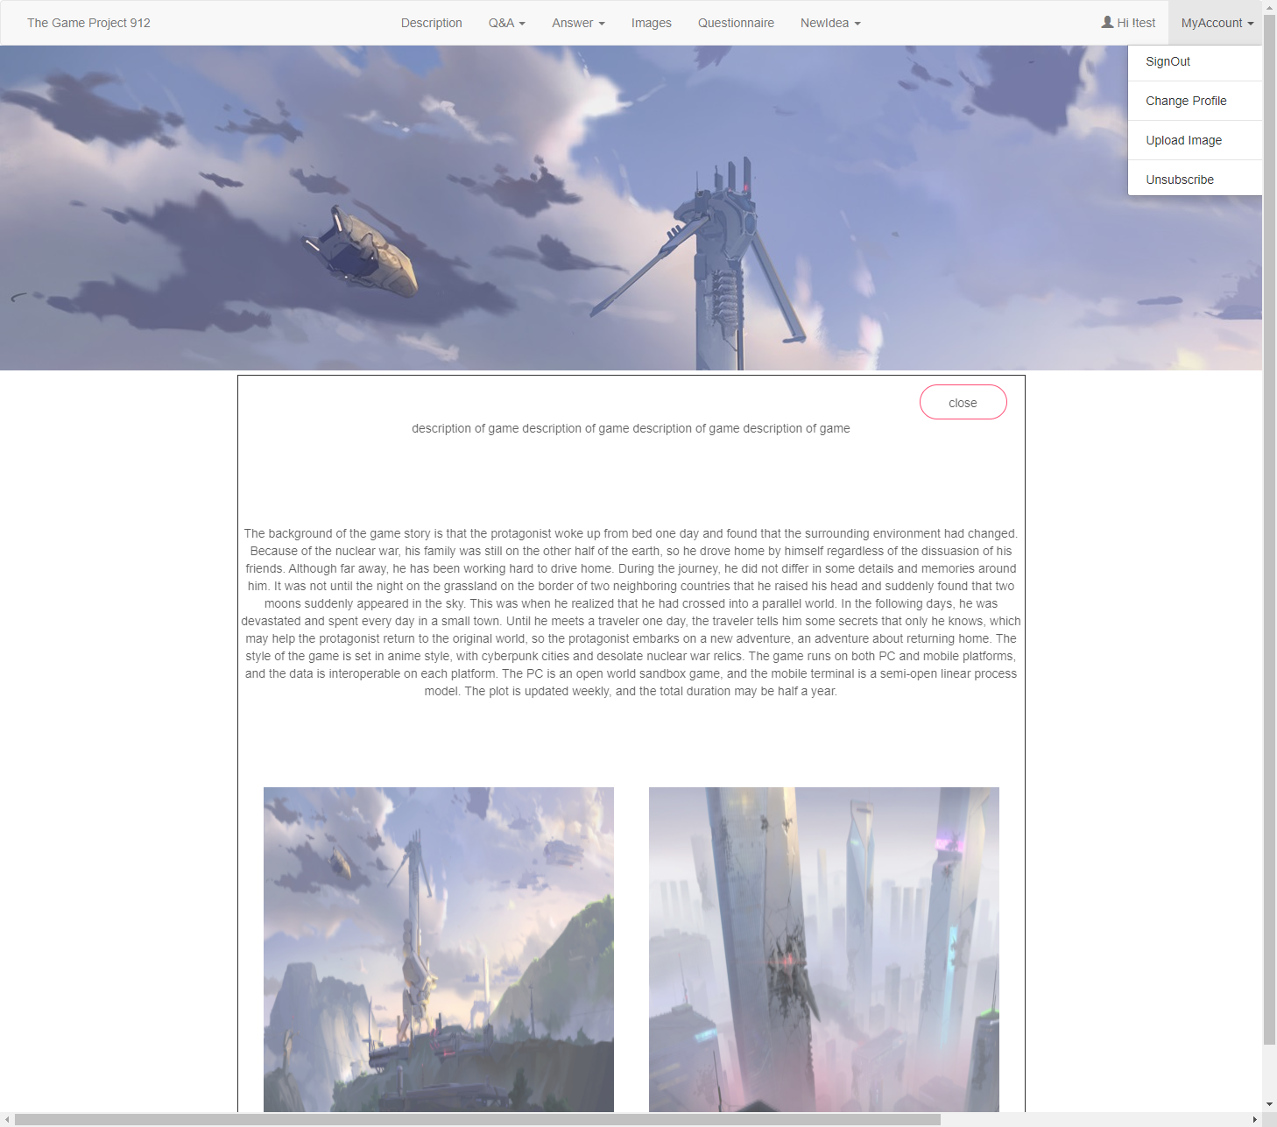

The “Q&A” part has three options post question, list question, and search question. We click the post question and enter the questions “test”, the question will store in the database “Question”, if we choose “search question” and enter the keywords t, the question will list on the page by a table. The “list question” will list all questions, such as the question “test”.

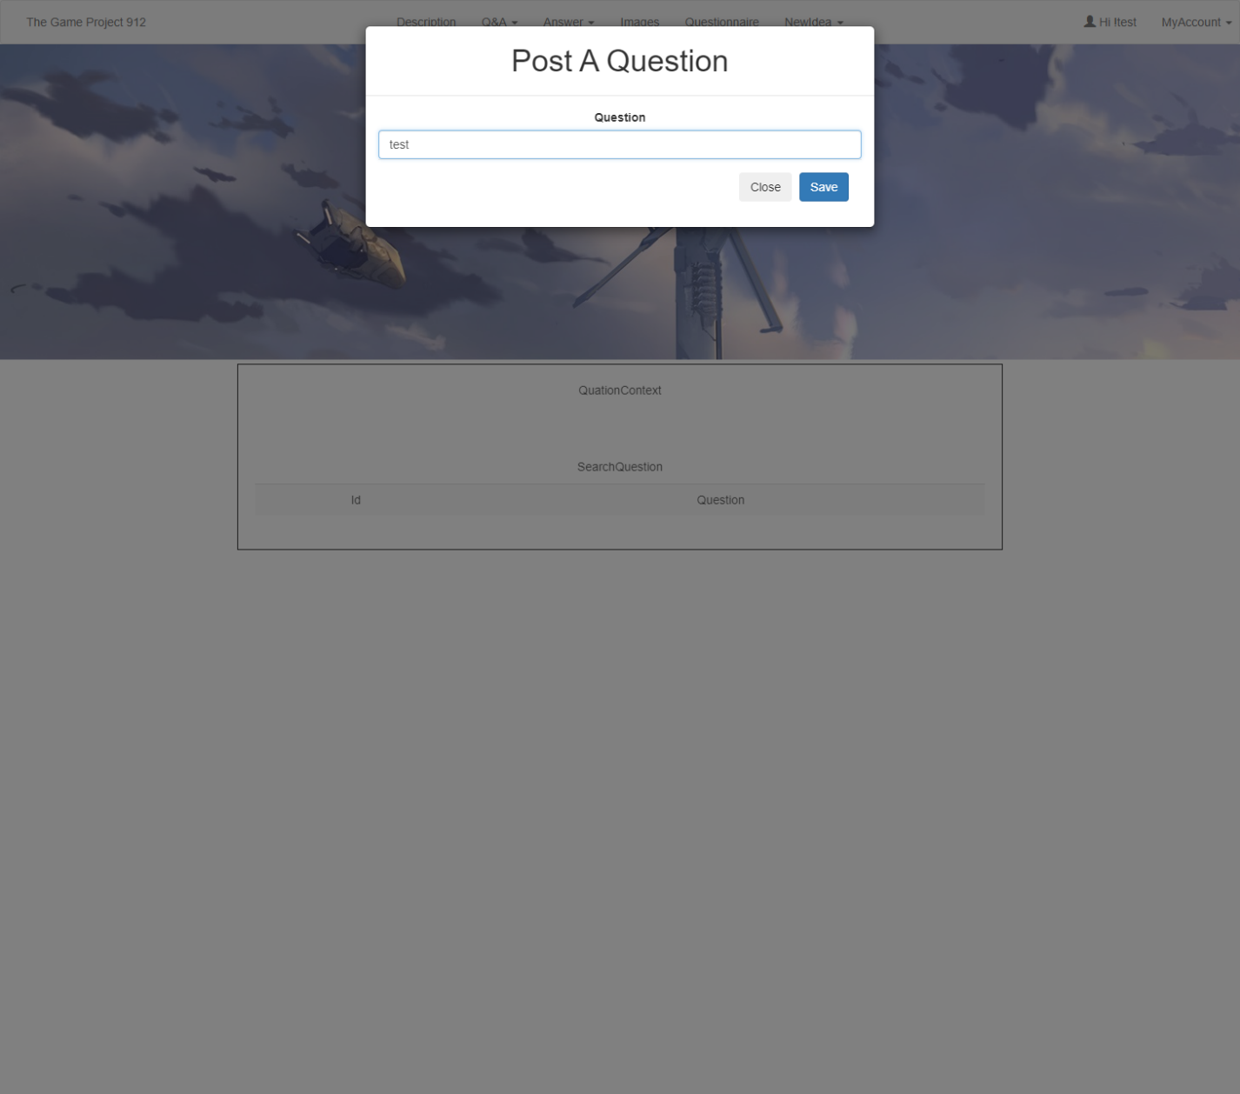

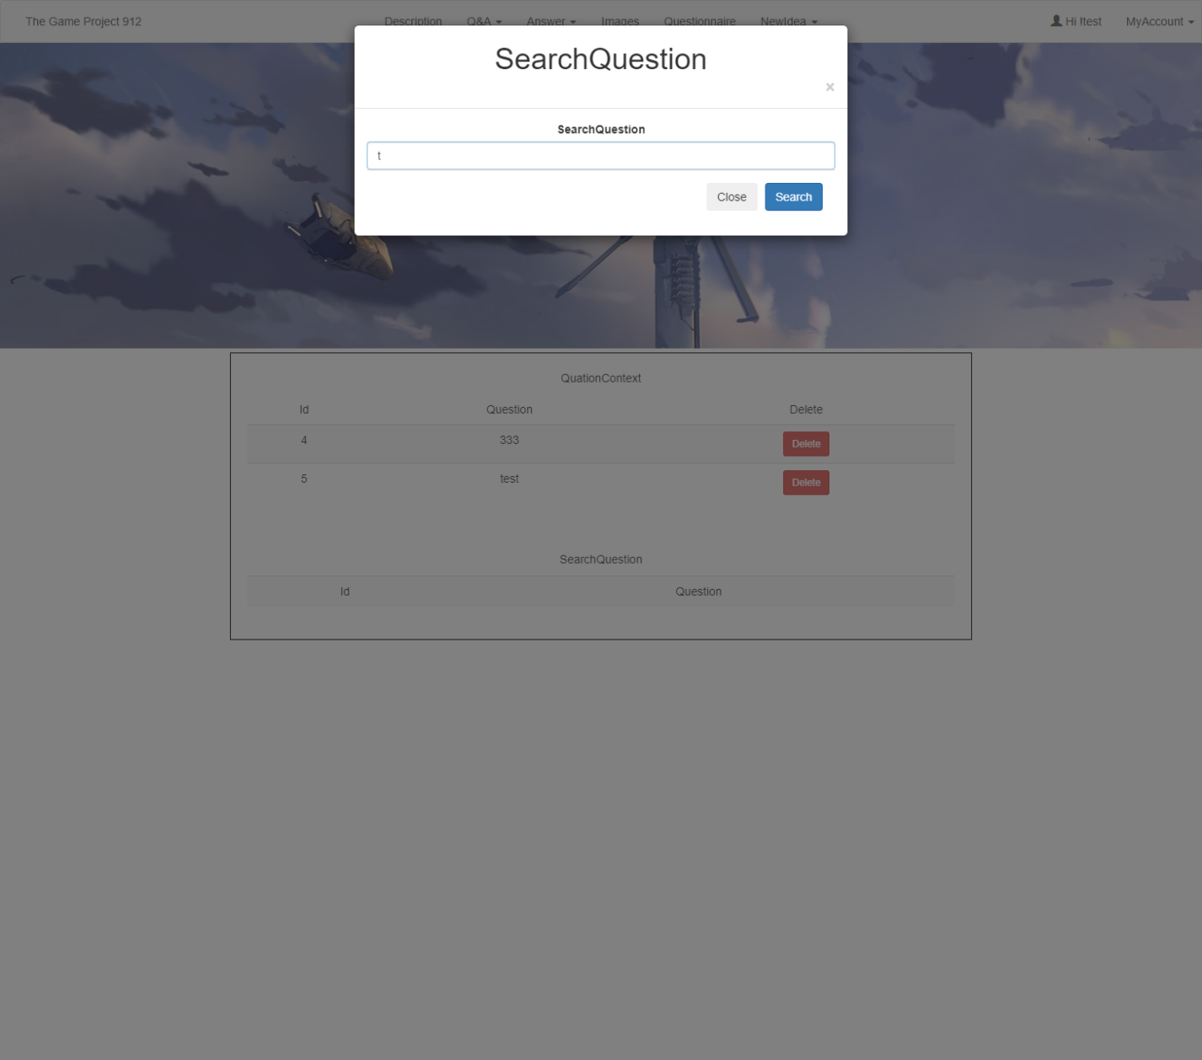

In the “Answer” part, user click “answer it” to answer the questions. After user answer the question, the question will store in the Answer Context in the database “Questions”, then the answer “test” will display in the database and “All Answer” table. If user click the list of all answers, and it will list answers and questions (answer “tset”). User can click the button “delete” to delete the question if they want to delete.

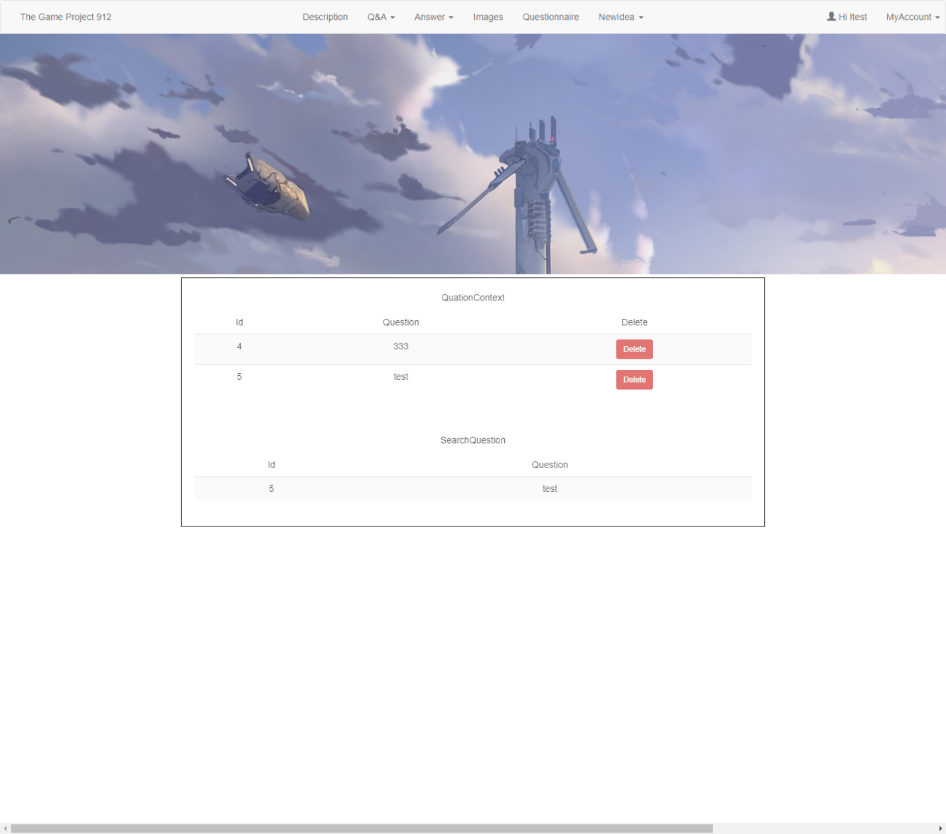

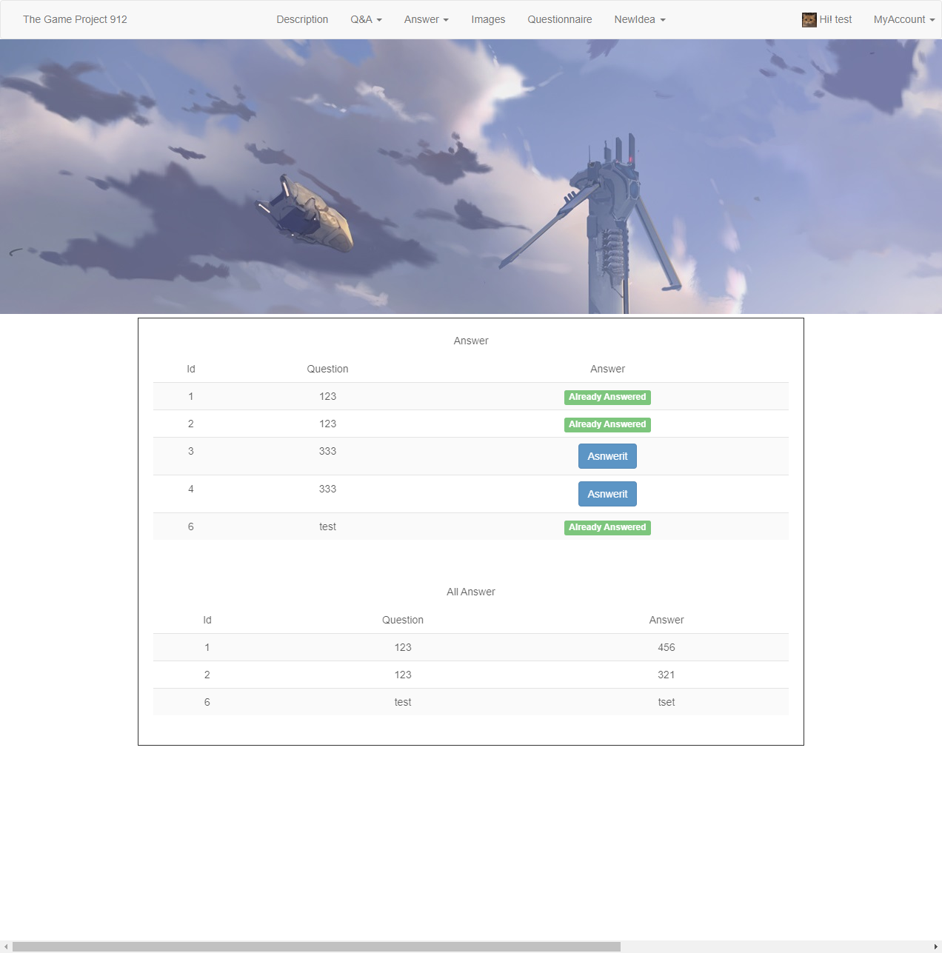

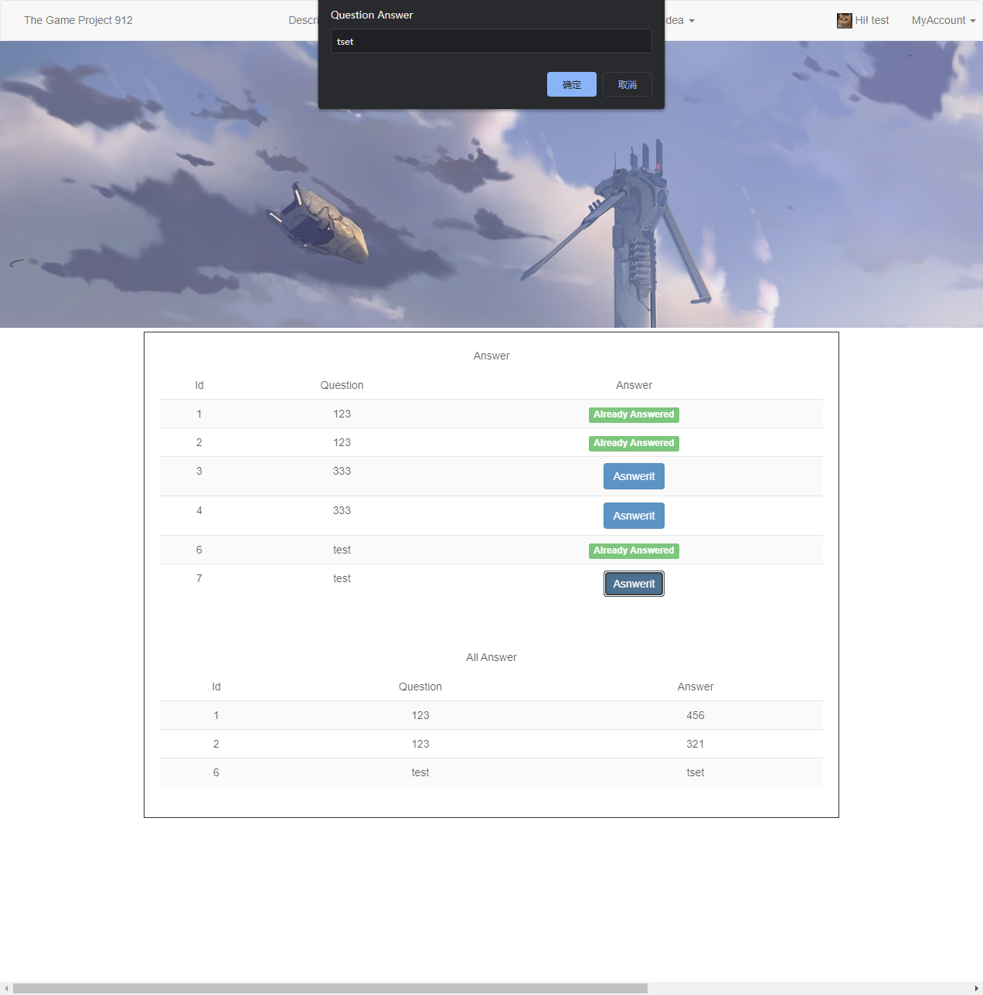

In the part of the images, user can upload the images by “upload image” in the menu “My Account” at the top right of the website. After user upload the image to the image part, the image will display in the part of images, the image “URL” will store in the database “UserImages”. Those images will upload into the “images” file in server. If user want to delete the images, user can click the “trash” icon behind the image to delete the image.



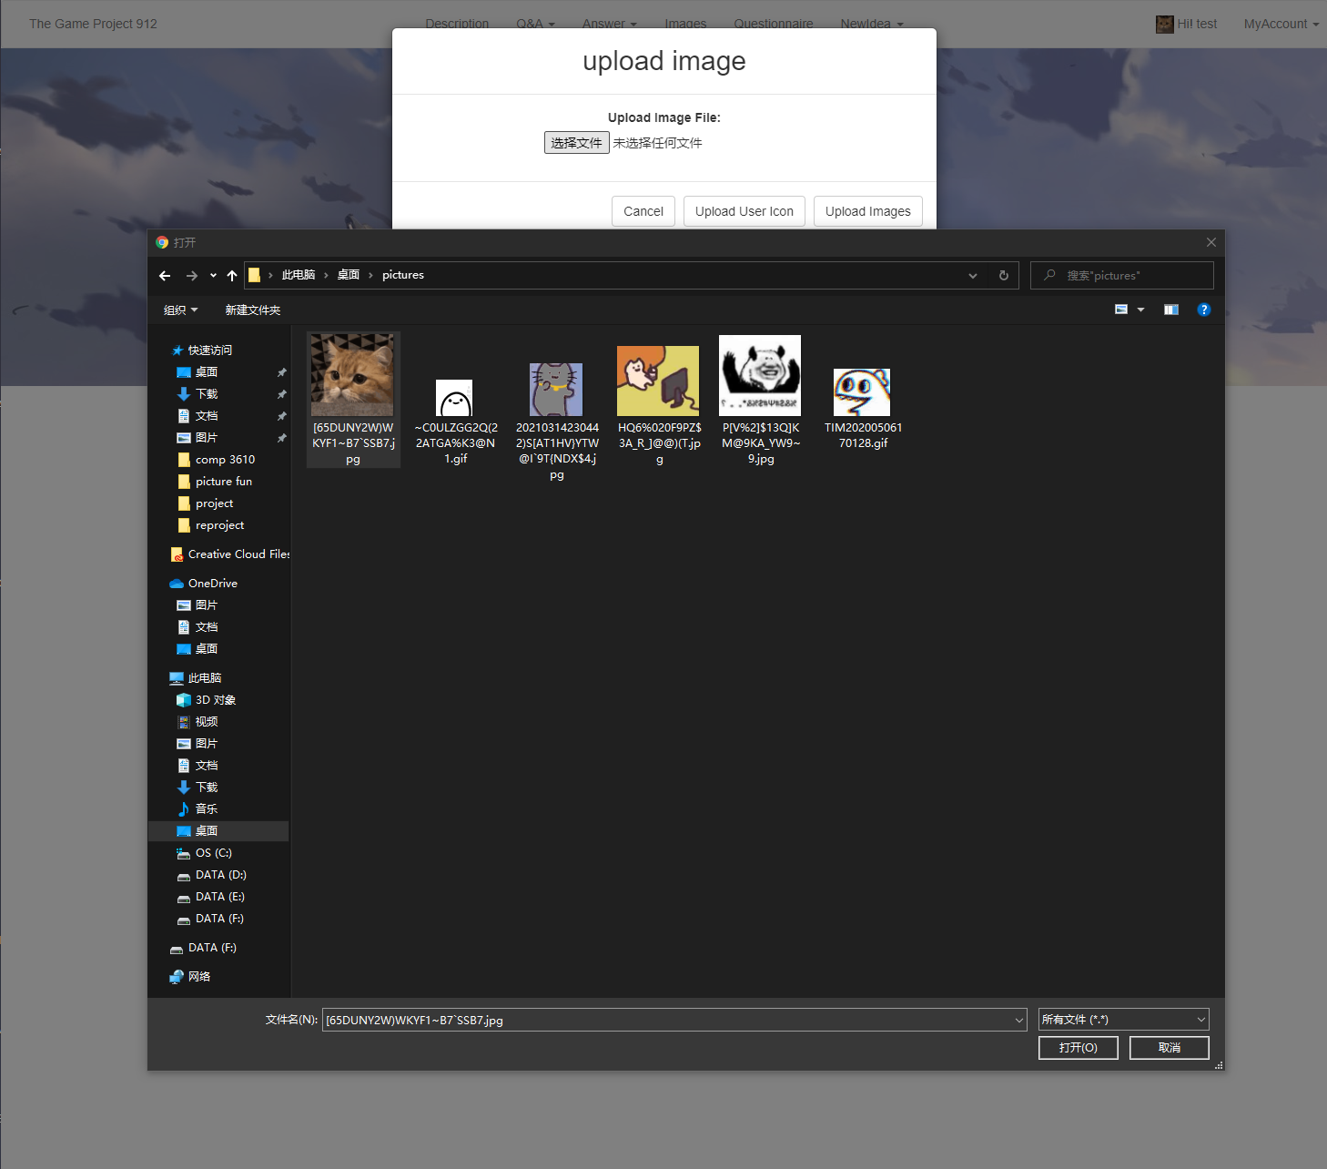

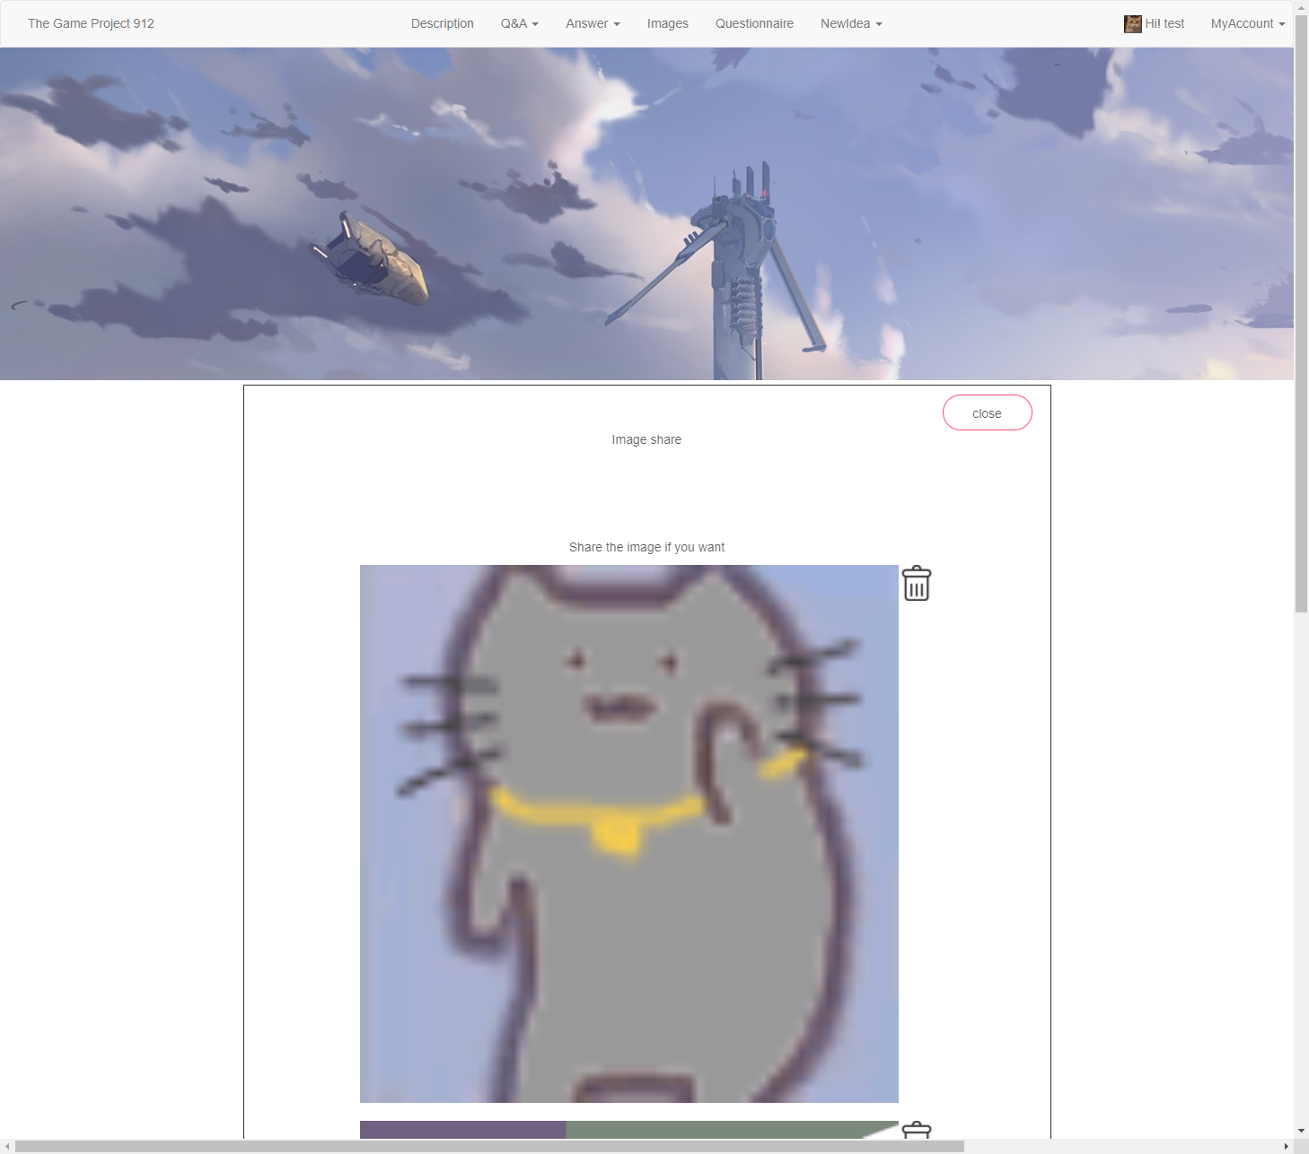

The Questionnaire has four questions to collect users’ messages and it will store in the database “Questionnaire”, in the database message will be stored after we entered: “1”,”2”,”3”,”4” with the “id”. The “new idea” part is very similar to the “Q&A” part but this part is used to collect ideas. User can post their ideas or just delete the questions.

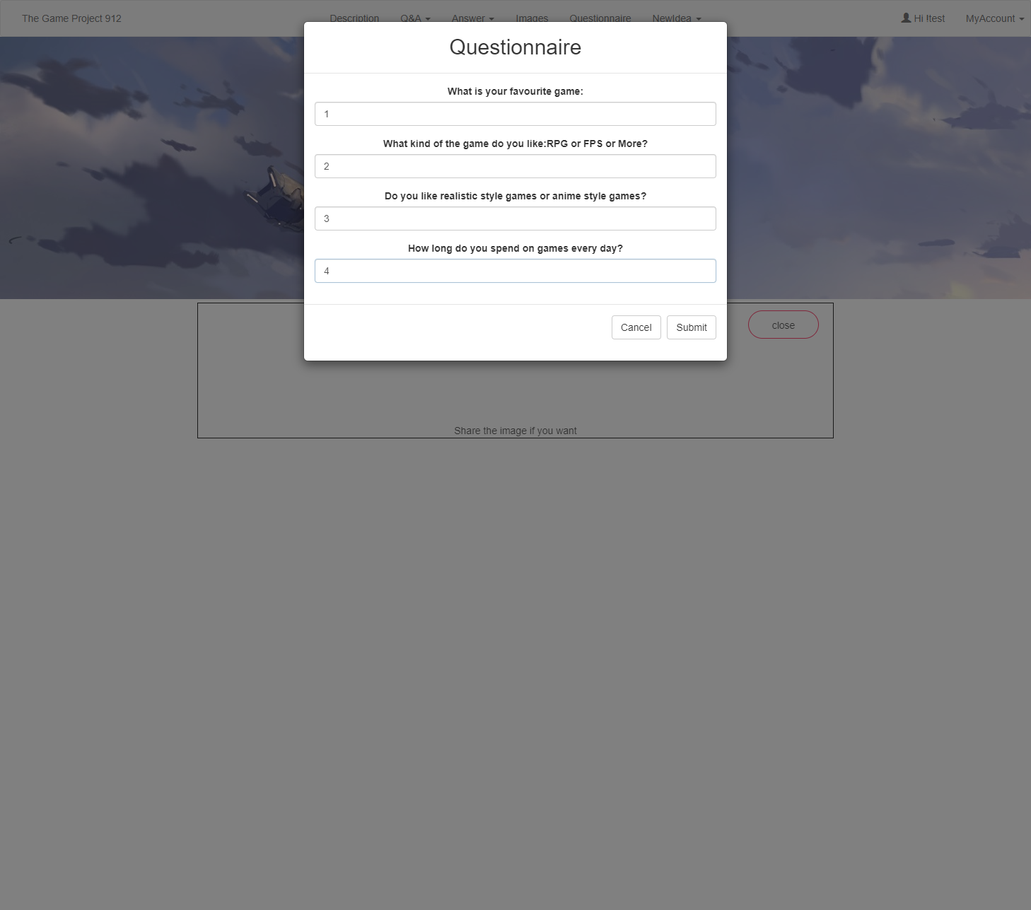

The New Idea parts is used to collect user’s idea and list all of them, user can also delete them. We type the new idea “test”, then we can see the idea “test” is displayed in the new idea table.

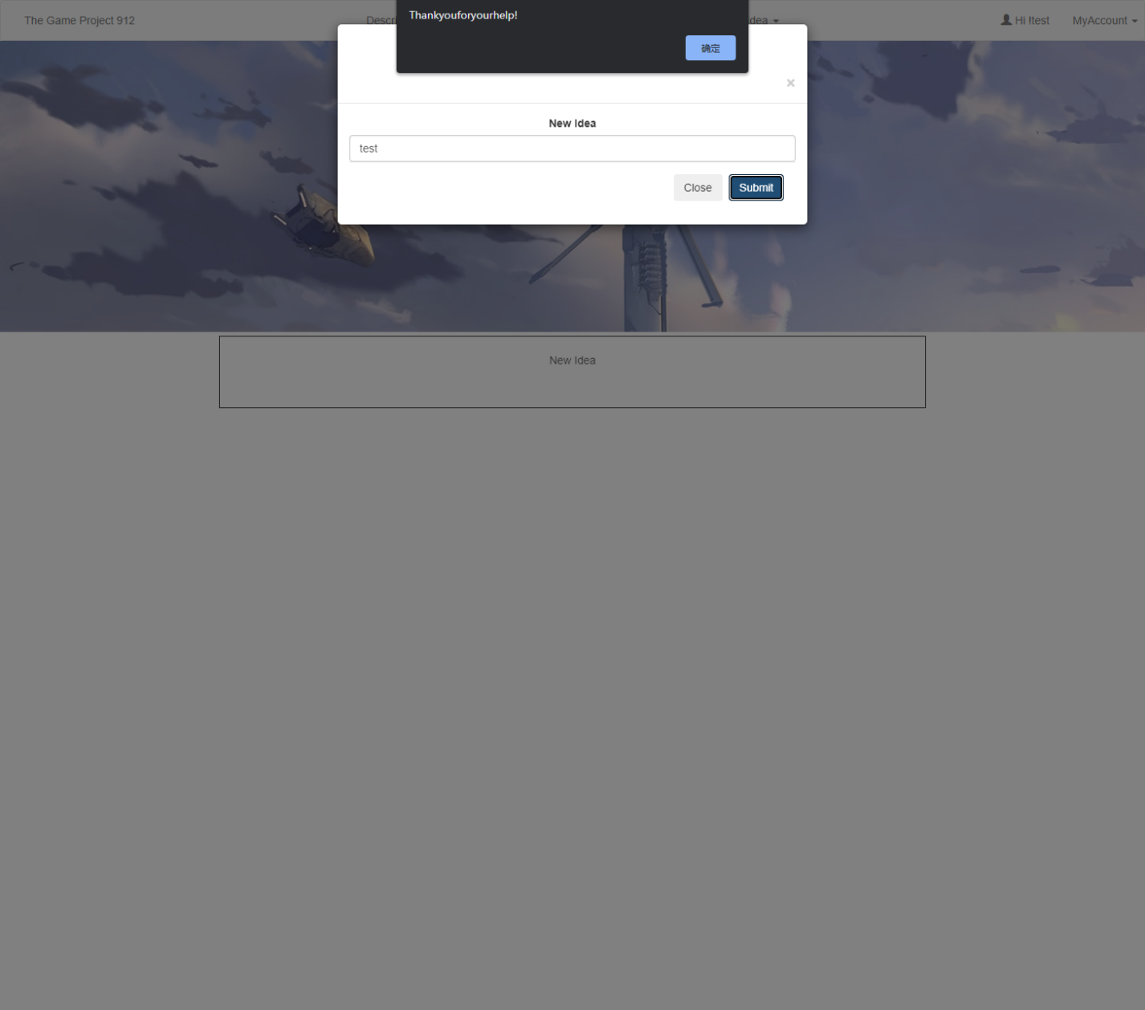

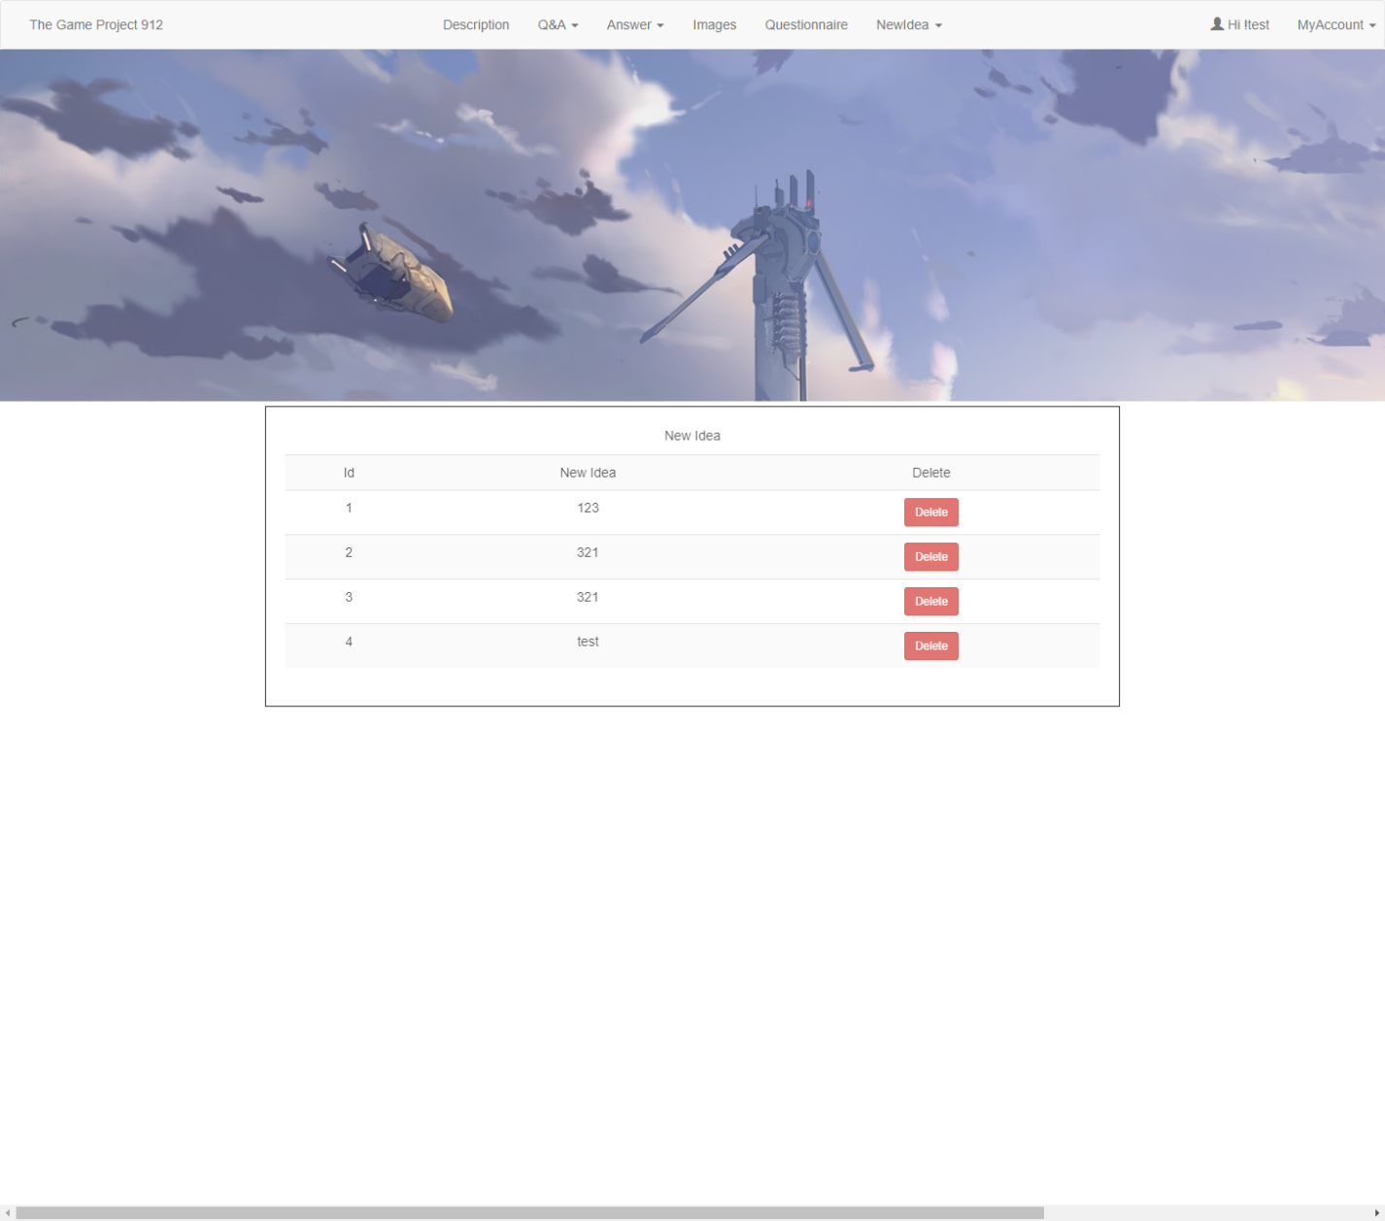

In the menu of “My Account”, there will be 4 options to choose from: “sign out”, “change profile”, “upload image” and “Unsubscribe”.

The uploaded image has two main options: “Upload User icon” and “Upload Image”. After we choose the image and upload it, the image will upload in the “images” file and the website(controller) will display those images by image’s “URL” ($filepath) and it will also store into the database. For user icon will store in the database the “UserLeng” value of “icon”. The images in the image will store in the database “User images”.





For change the password we need to click the “Change Profile”, after we enter the username and password, the password will be changed.

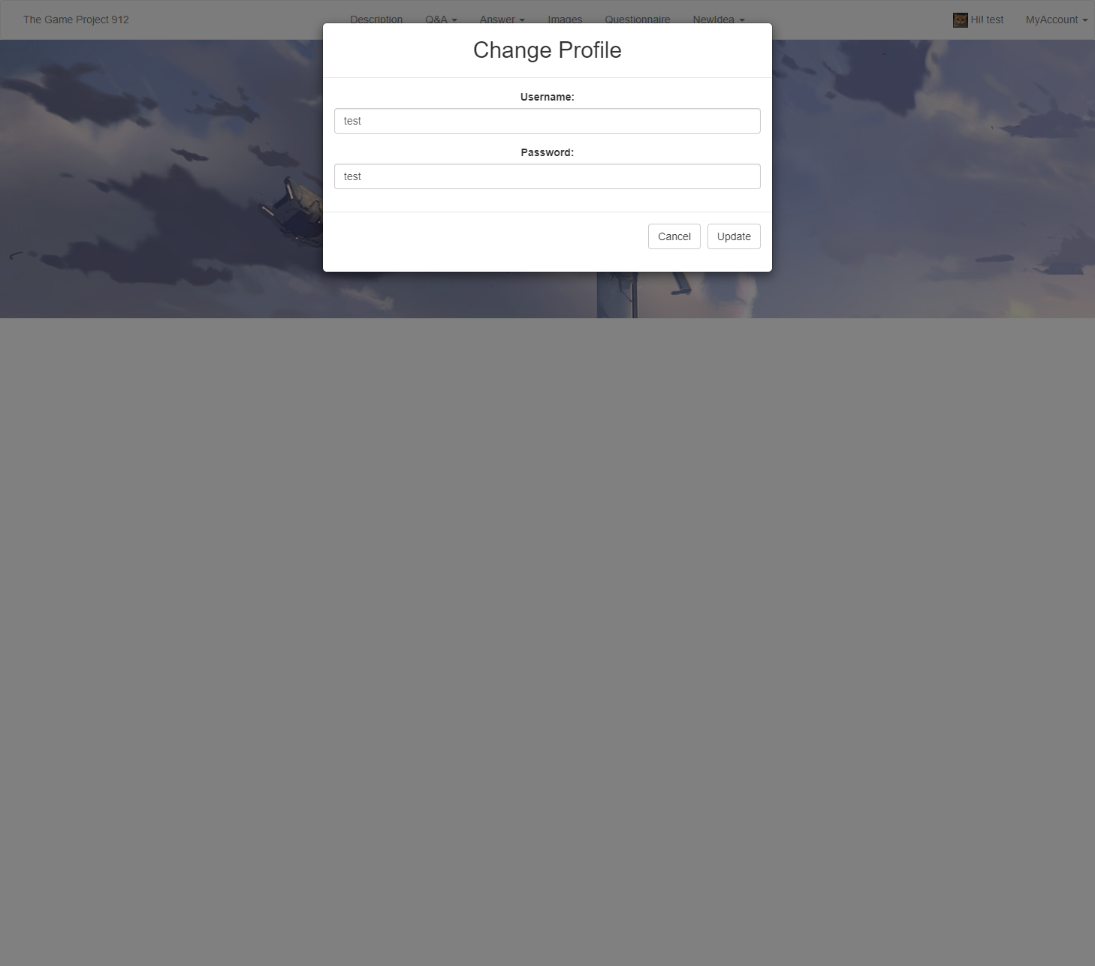



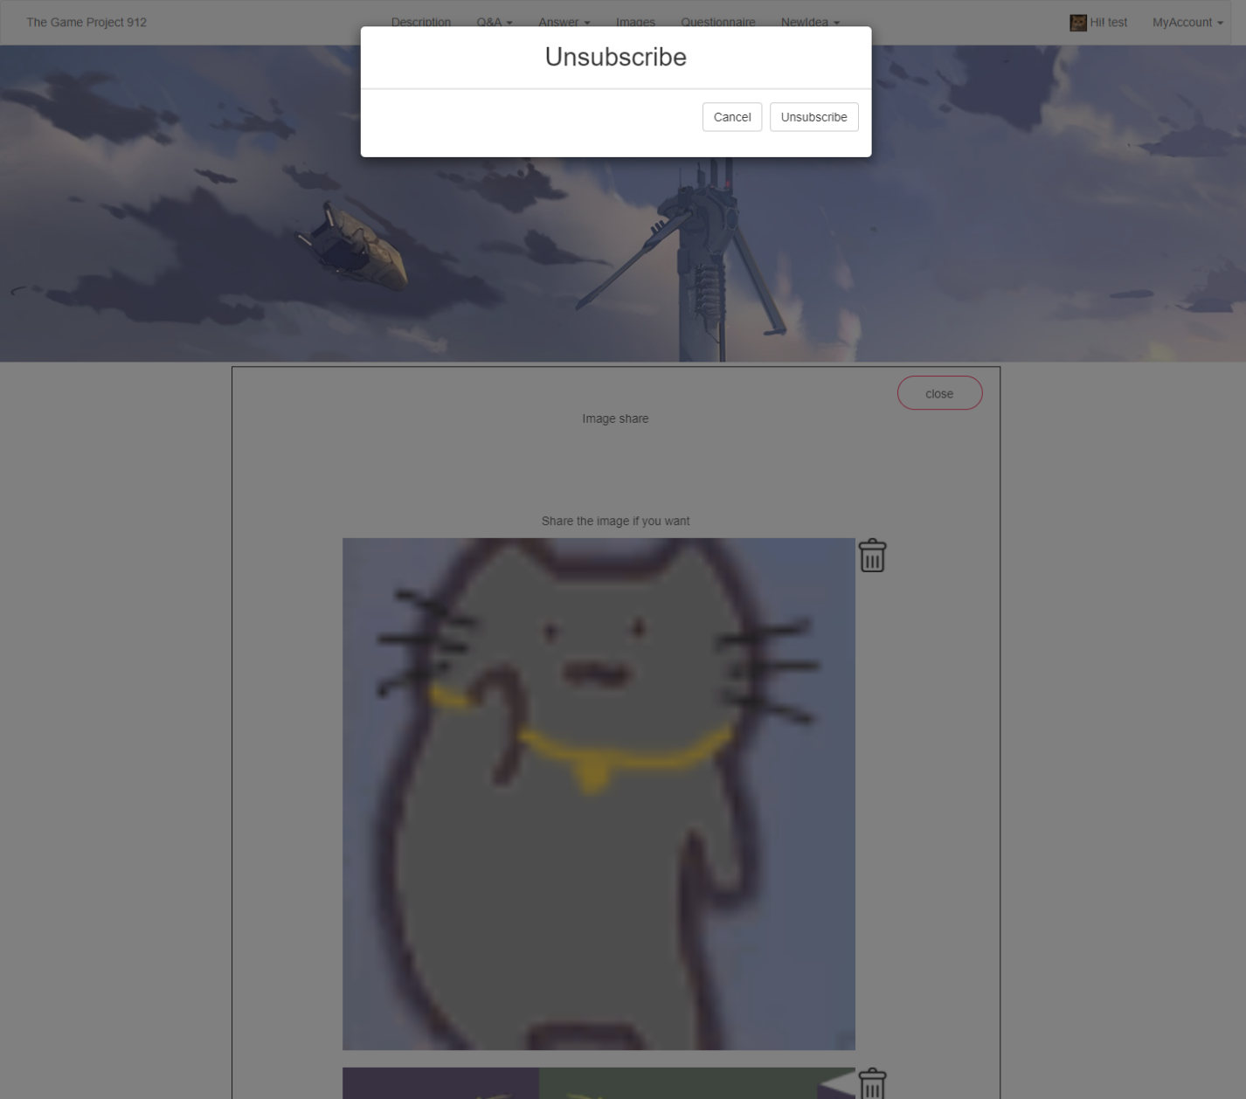The “sign out” option will let users sign out from the main page and back to the start page. The changing profile is used to change the user’s login information(password) and unsubscribe could let the user delete their login information from the website, and the user will not be able to log in to the website by their current password and username. And both of two function will make user back to the start page after alert messages.

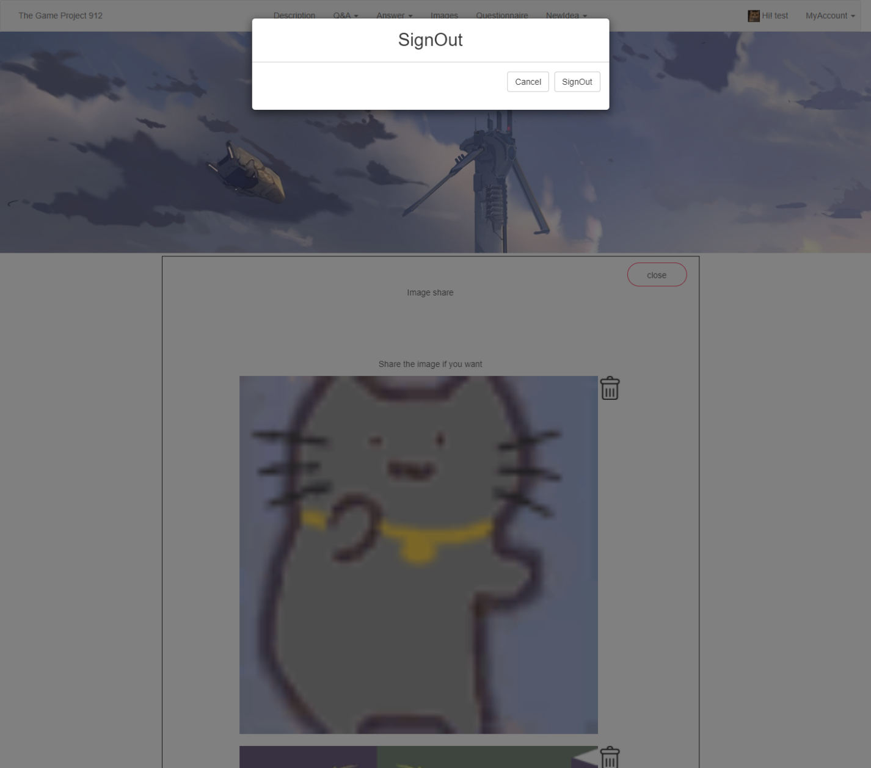

**Database details:**

